Name of Student : Raghav Mahesh Sarda PRN: 25070122235
Subject: Programming with Java Semester: III
ASSIGNMENT No : 11 Year: AY 2026-27
TITLE : Interface Implementation

Problem Statement
Write a Java program to demonstrate the implementation of interfaces.

Learning Objectives
To implement interfaces for achieving abstraction and multiple inheritance of type.

Program:
InterfaceStudentEmployee.java
// Assignment 11 - Exercise 1: Printable Interface
import java.util.*;
interface Printable // Interface declaration
{
void printDetails(); // Abstract method
}

class Student implements Printable // Implementing interface in Student
{
String name;
int roll;

Student(String n, int r) // Constructor
{
name = n;
roll = r;
}
public void printDetails() // Overriding interface method
{
System.out.println("Student Details -> Name: " + name + ", Roll No: " + roll);
}
}

class Employee implements Printable // Implementing interface in Employee
{
String empname;
int empid;
Employee(String n, int id) // Constructor
{
empname = n;
empid = id;
}
public void printDetails() // Overriding interface method
{
System.out.println("Employee Details -> Name: " + empname + ", ID: " + empid);
}
}

public class InterfaceStudentEmployee
{
public static void main(String args[]) // Main method
{
Scanner sc = new Scanner(System.in);
System.out.print("Enter Student Name: ");
String sn = sc.nextLine();
System.out.print("Enter Student Roll No: ");
int sr = sc.nextInt();
sc.nextLine(); // Consuming newline
System.out.print("Enter Employee Name: ");
String en = sc.nextLine();
System.out.print("Enter Employee ID: ");
int ei = sc.nextInt();

Printable p1 = new Student(sn, sr); // Interface reference to Student object
Printable p2 = new Employee(en, ei); // Interface reference to Employee object

System.out.println(" ");
p1.printDetails(); // Calling overridden method for student
p2.printDetails(); // Calling overridden method for employee
sc.close();
}
}

SwitchableInterface.java
// Assignment 11 - Exercise 2: Switchable Interface
import java.util.*;
interface Switchable // Interface declaration
{
void turnOn(); // Abstract method
}

class Light implements Switchable // Implementing interface
{
String room;
Light(String r) // Constructor
{
room = r;
}
public void turnOn() // Overriding method
{
System.out.println("Light in " + room + " is now TURNED ON.");
}
}

class Fan implements Switchable // Implementing interface
{
int speed;
Fan(int s) // Constructor
{
speed = s;
}
public void turnOn() // Overriding method
{
System.out.println("Fan is now TURNED ON at speed " + speed + ".");
}
}

public class SwitchableInterface
{
public static void main(String args[]) // Main method
{
Scanner sc = new Scanner(System.in);
System.out.print("Enter Room for Light: ");
String rm = sc.nextLine();
System.out.print("Enter Fan Speed (1-5): ");
int sp = sc.nextInt();

Switchable s1 = new Light(rm); // Interface reference to Light
Switchable s2 = new Fan(sp); // Interface reference to Fan

System.out.println(" ");
s1.turnOn(); // Executing Light method
s2.turnOn(); // Executing Fan method
sc.close();
}
}

Output:
InterfaceStudentEmployee.java
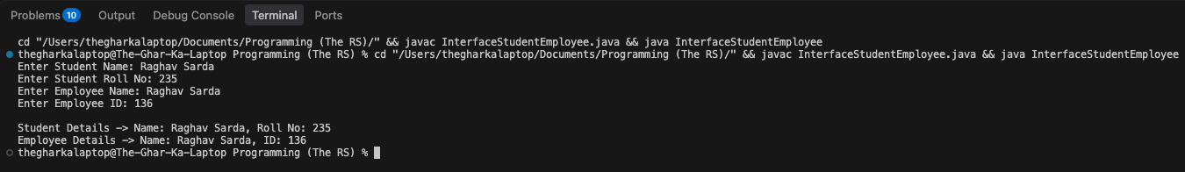

SwitchableInterface.java
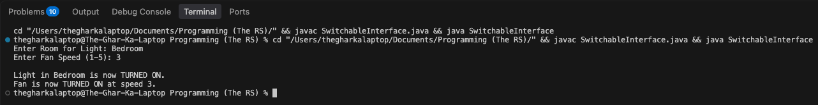

Conclusion:
In this assignment, concepts of pure abstraction and multiple inheritance of type using interfaces were successfully implemented and verified. Interfaces provided a unified specification that distinct, unrelated classes like Student and Employee or Light and Fan adhered to, ensuring standardized method implementation and promoting high code modularity and loose coupling across the program.

